**Carissa Ying Geok Teng**

**A0205190R**

**CW2**

**Q1**

The General Hough Transform (GHT) can detect a predefined shape using 3 main parameters; the position of the reference point of the shape, the orientation of the shape, and the scale. The scale can comprise of 2 orthogonal scale factors. To start the GHT algorithm, for each edge, the edge direction, distance to the reference point, and angle to the reference point are measured.

In the case of a soccer ball, the shape can be described as a circle. A good reference point would be the centre of the circle. The distance to the reference point will be constant for all edges. The angle to the reference point will be the same as the edge direction.

There might be multiple circles in one image, like in wm74_1.bmp where there is a larger outer circle, or in wm74_2.bmp where there are smaller ‘O’s in the background. If it is known that the soccer ball will not exceed or go below a certain size on the image, it might be good to set a limit to the scale.

Additionally, in images, the soccer ball might be distorted, like in cases of a scan like wm74_1.bmp. Since the scale can comprise 2 orthogonal factors, the scaling can be set to stretch or squash the circle. To prevent ellipses that are too stretched, the scale ratio can be restricted to be close to 1 with a small tolerance.

**Q2**

Orthogonal Transformations are linear transformations on signals such that the inner products are preserved.

Mathematically, for any 2 elements, (u, v), in the real inner product space. $u ∙v$ is the inner product. If a transformation, A, is applied on u and v respectively to get (Au, Av).

$Au∙Av={\left(Au\right)}^{T}\left(Av\right)=u^{T}A^{T}Av$

If A is orthogonal, then $A^{T}A=I$

Hence, $u^{T}A^{T}Av=u^{T}v=u∙v$, and the inner products are preserved

This is useful in signal processing as the signal can be transformed with an orthogonal transformation, a filter can be applied, then the signal can be transformed back without phase information.

Orthonormal Transformations are orthogonal transformations that preserve the signal amplitude.

Mathematically, for any element, u, in the real inner product space. If a transformation, A, is applied on u to get Au.

If for each column of A, $\left\|a_{i}\right\|=1, Au=u$

**Q3**

circles1.bmp:

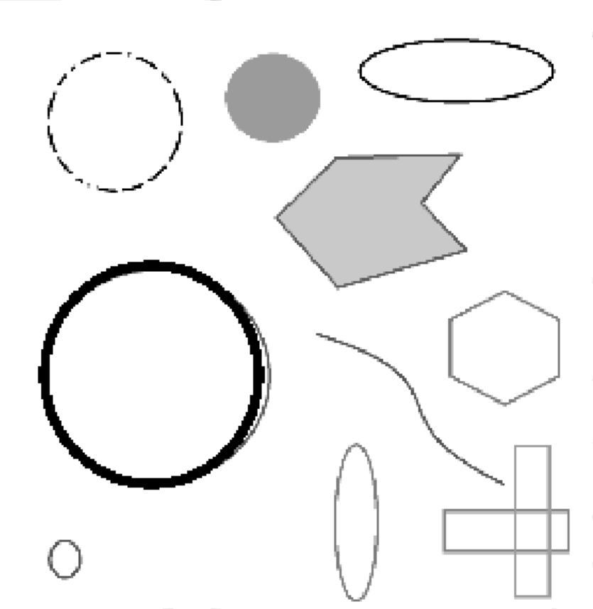

95103.png:



**Q4**

01a_amusementpark.jpg:

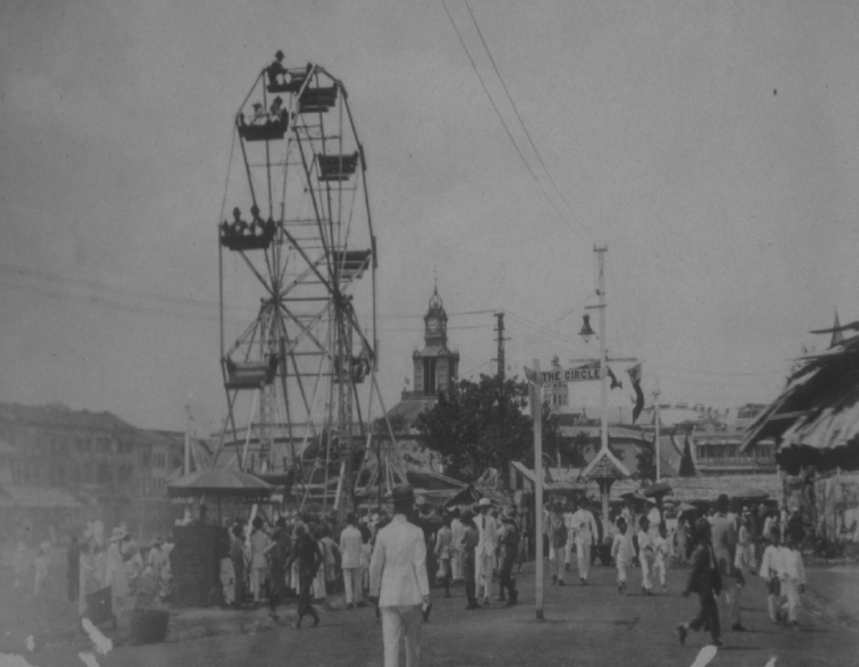

Original power: 14284.92

[0.1, 0.4]:

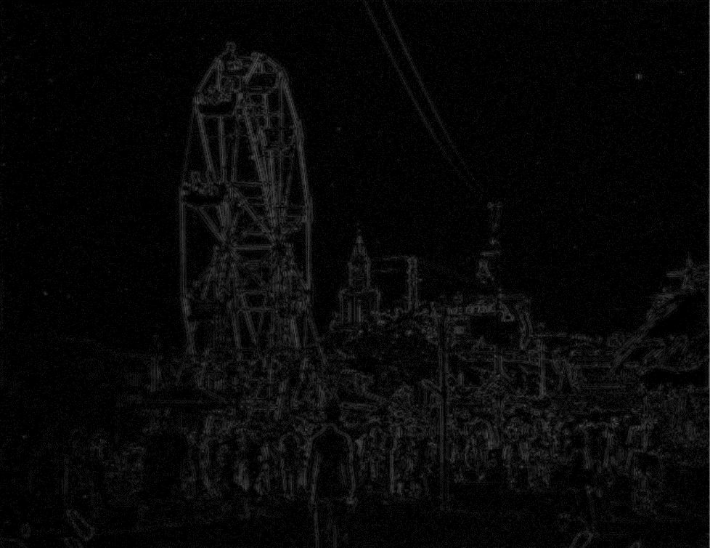

Power: 19.23

[0.3, 0.4]:

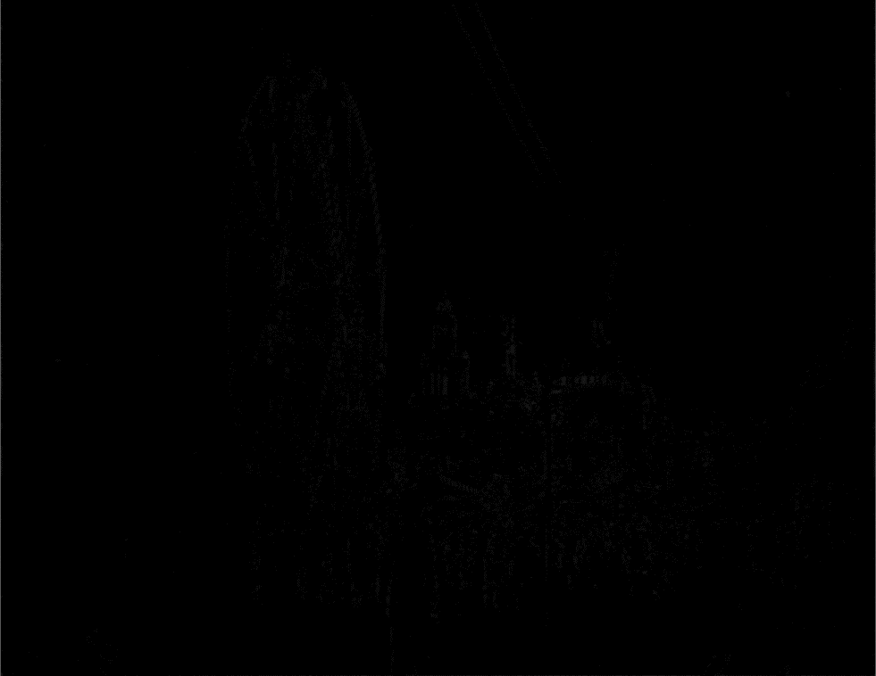

Power: 0.36

JASDF-1111_.jpg:

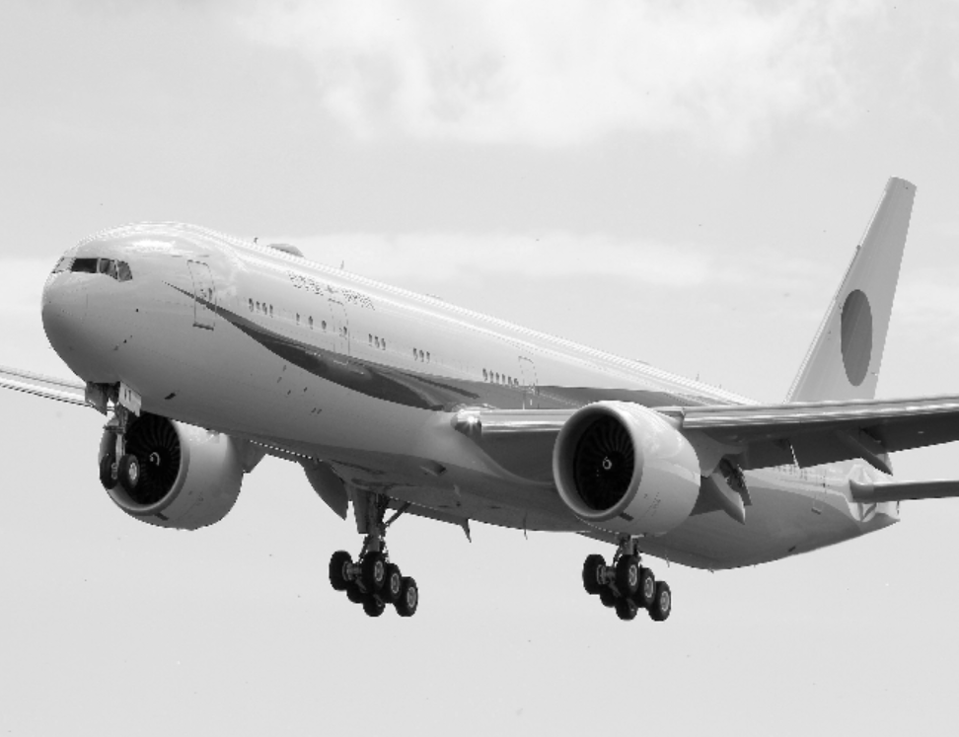

Original power: 42251.40

[0.1, 0.4]:

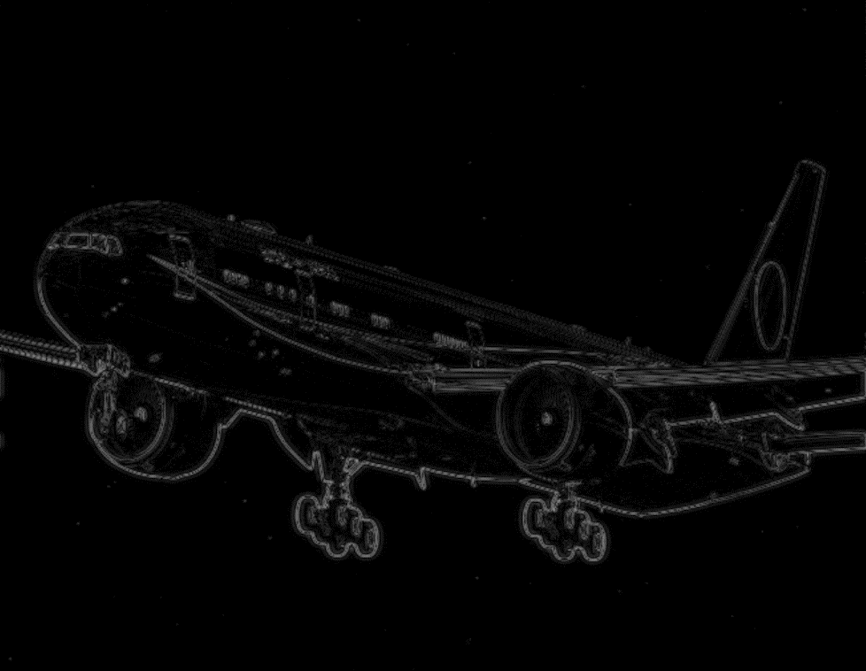

Power: 44.85

[0.3, 0.4]:

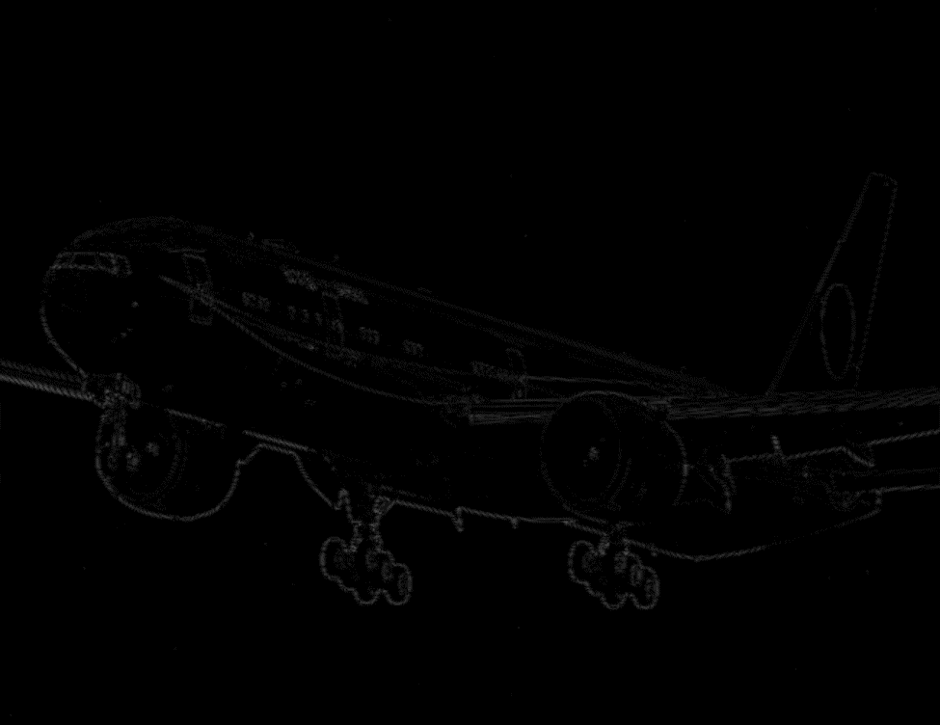

Power: 3.26

**Q5**:

BBtpZbO.jpg:

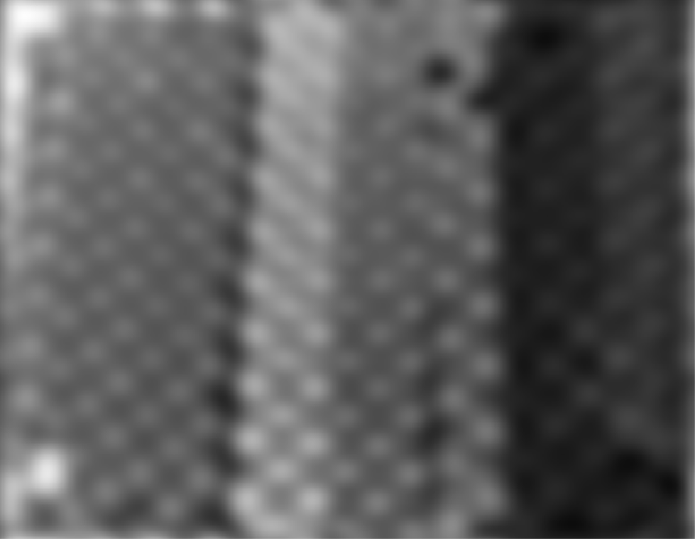 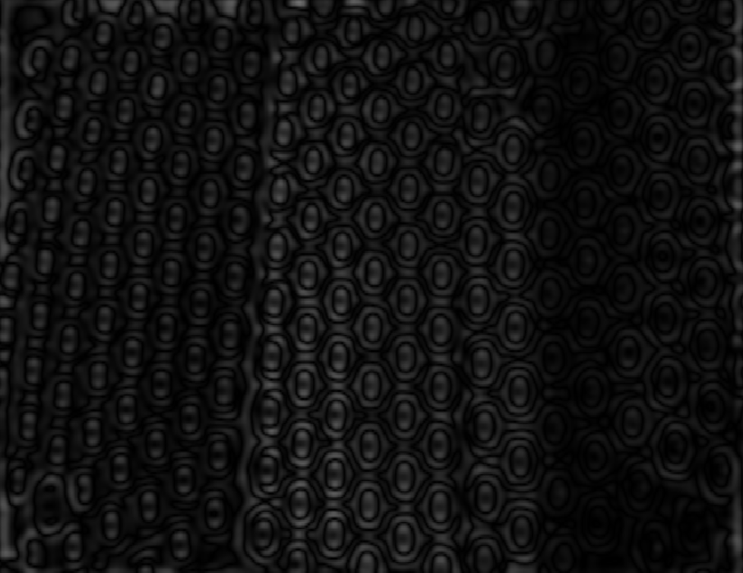 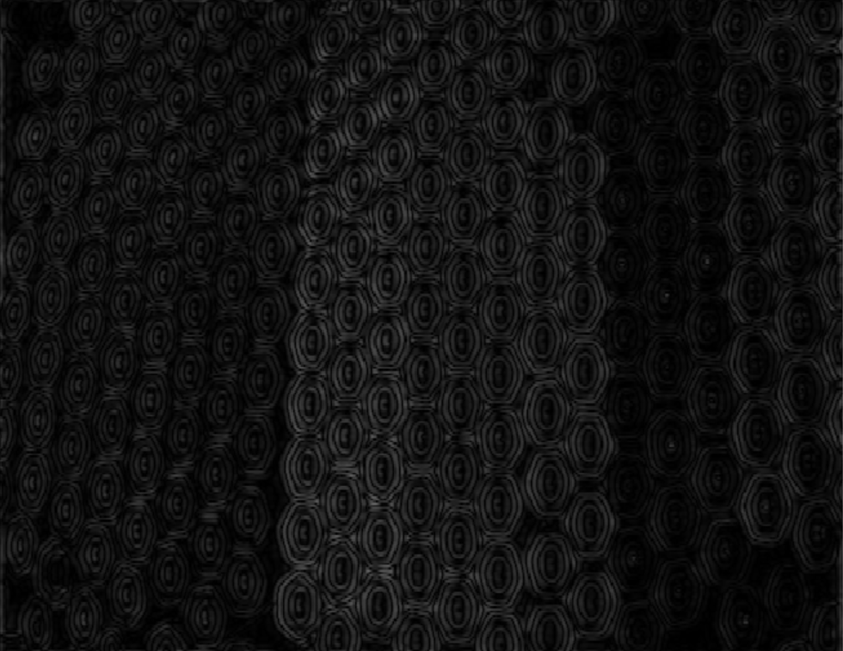

|  |  |  |  |
| --- | --- | --- | --- |
| Low CF | High CF | Power | Power % |
| 0 | 0.1 | 10223.79 | 83.23 |
| 0.1 | 0.3 | 486.12 | 3.96 |
| 0.3 | 0.7 | 495.31 | 4.03 |

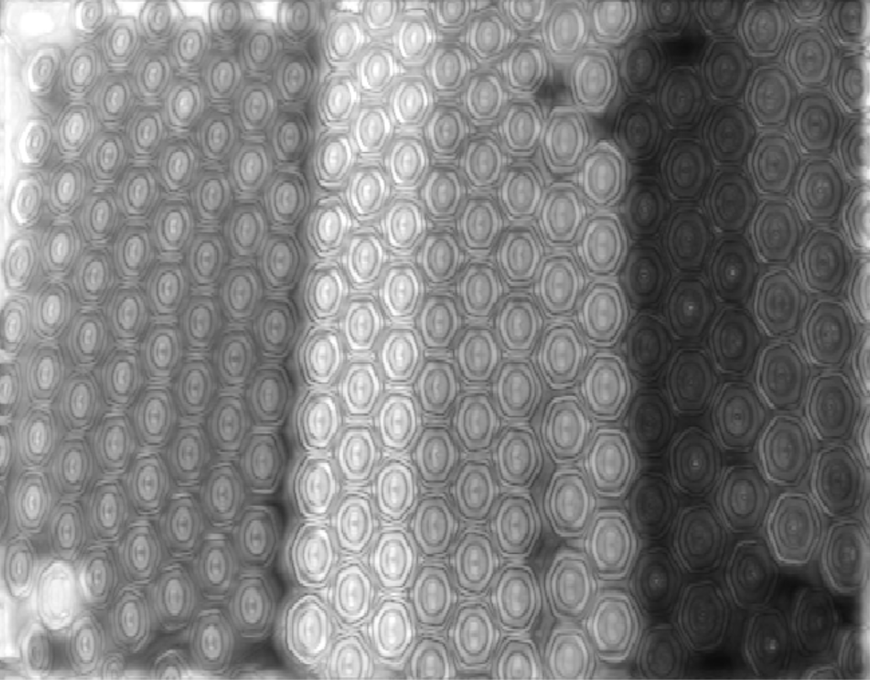

djzam_nat_defect_002_2g_8.bmp:

  

|  |  |  |  |
| --- | --- | --- | --- |
| Low CF | High CF | Power | Power % |
| 0 | 0.1 | 27708.43 | 99.35 |
| 0.1 | 0.3 | 5.06 | 0.02 |
| 0.3 | 0.7 | 1.02 | 0.00 |

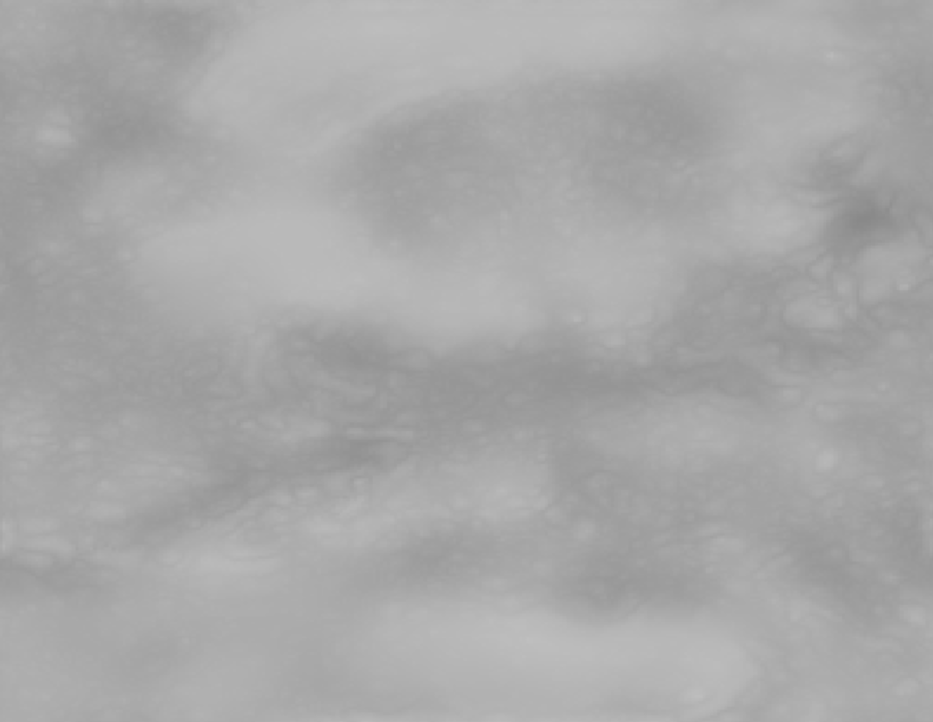

When the bandpass filter is [0, 0.1] most of the power of the image is still high. This is likely because most images have a higher concentration of lower frequencies. Hence, although the band is small, it does not significantly remove many of the frequencies in the image.

**Q6:**

IMG_0358.JPG:

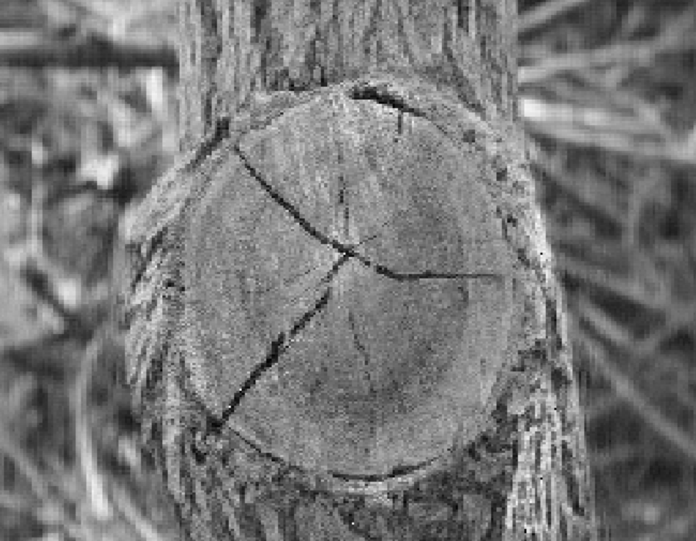 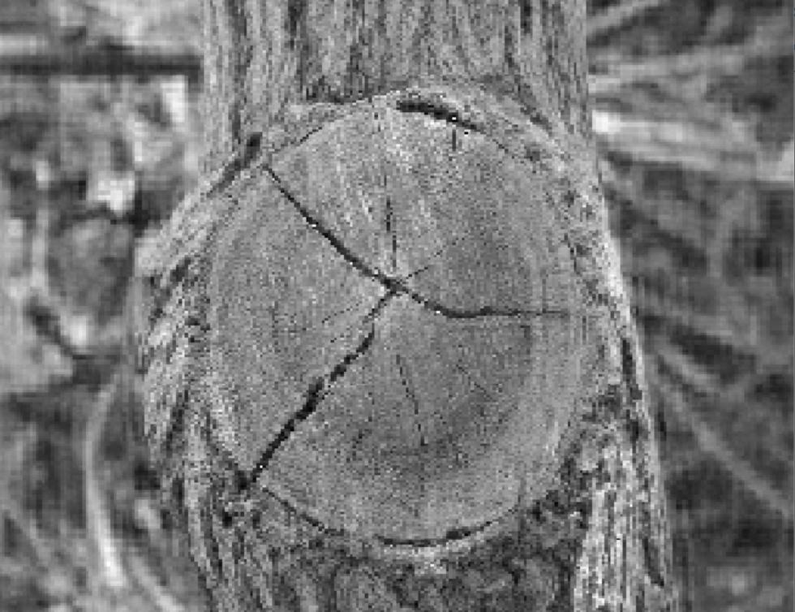

|  |  |  |  |
| --- | --- | --- | --- |
| Low CF | High CF | Power | Power % |
| 0.6 | 0.9 | 15769.02 | 98.16 |
| 0.4 | 0.6 | 15794.78 | 98.32 |

06600600u.bmp:

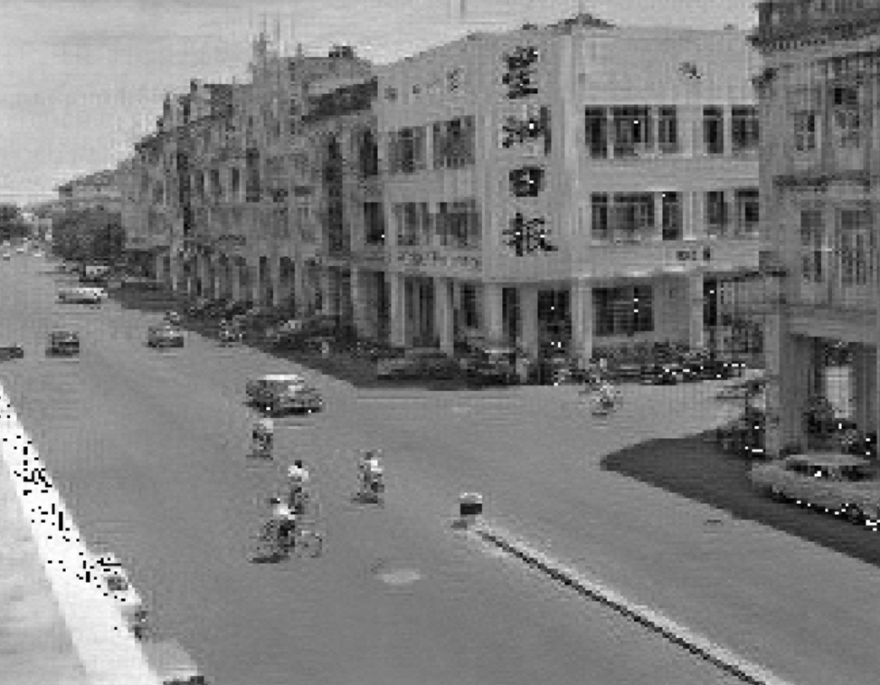 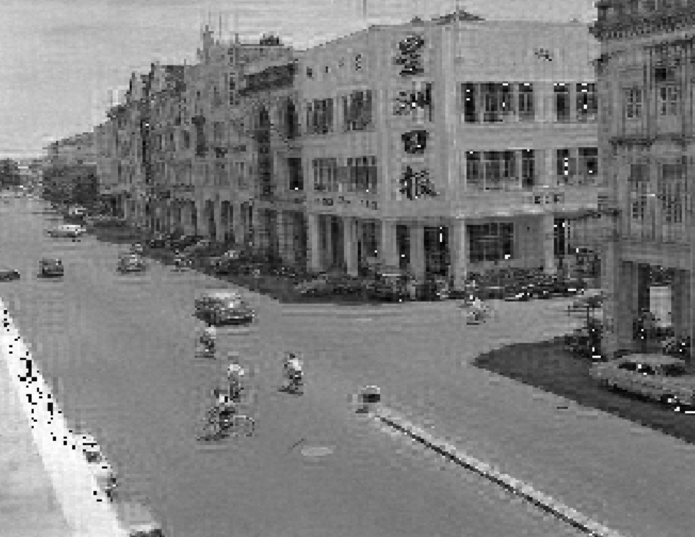

|  |  |  |  |
| --- | --- | --- | --- |
| Low CF | High CF | Power | Power % |
| 0.6 | 0.9 | 17428.42 | 98.13 |
| 0.4 | 0.6 | 17495.52 | 98.51 |